1. What is the Collection framework in Java?
Ans: Collection Framework is a combination of classes and interface, which is used to store and manipulate the
data in the form of objects. It provides various classes such as ArrayList, Vector, Stack, and HashSet, etc. and
interfaces such as List, Queue, Set, etc. for this purpose.
2. What is the difference between ArrayList and LinkedList?
Ans:
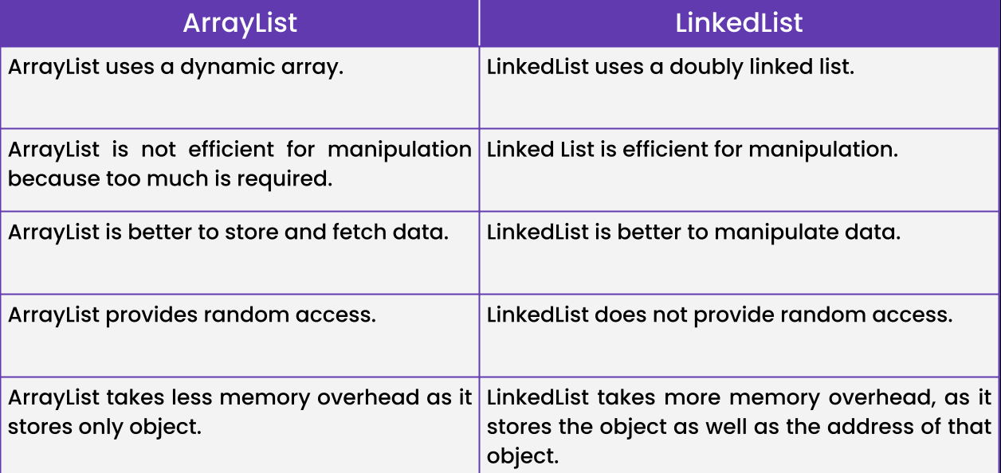

3. What is the difference between Iterator and ListIterator?
Ans:
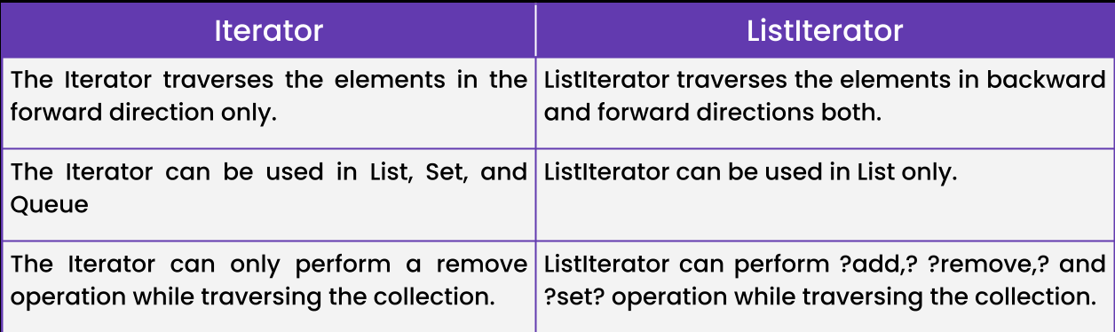

4. What is the difference between Iterator and Enumeration?
Ans:

5. What is the difference between List and Set?
Ans:
 | List | Set
Order | Ordered | Unordered
Duplicates | Allow duplicates | No duplicates
Access | Accessed using index | No index, accessed using iterator
Implementation | ArrayList, LinkedList, Vector, etc. | HashSet, TreeSet, LinkedHashSet, etc.

6. What is the difference between HashSet and TreeSet?
Ans:

 | HashSet | TreeSet
Ordering | Unordered | Sorted based on natural ordering or a custom comparator
Performance | Faster for add, remove, and lookup operations | Slower for add, remove, and lookup operations
Memory Usage | Uses less memory | Uses more memory
Null Elements | Allows null elements | Does not allow null elements
Implementation | Uses a hash table | Uses a balanced tree

7. What is the difference between Array and ArrayList?
Ans:
 | Array | ArrayList
Size | Fixed | Dynamic
Type | Can hold elements of any data type, including primitives | Can only hold objects
Memory allocation | Allocates memory as a contiguous block | Allocates memory as an array of objects
Performance | Faster for accessing elements | Slower for accessing elements due to the need for dynamic resizing
Operations | Limited operations | Provides many operations, such as adding, removing, and resizing
Initialization | Requires a fixed size and explicit initialization | Can be initialized without a fixed size

